Multimodal Insurance Creator

Report

  - Course Name: Gen AI

Institution Name: Medicaps University – Datagami Skill Based Course

Student Name(s) & Enrolment Number(s):
Sr no | Student Name | Enrolment Number
1 | Ishita Garg | EN22CS301446
2 | Janvi Mahajan | EN22CS301455
3 | Ishita Jain | EN22CS301447
4 | Janak Dalke | EN22CS301452
5 | Irya Patni | EN22CS301436

Group Name: D404
Project Number: GAI-40
Industry Mentor Name:
University Mentor Name: Pof. Divya Kumawat
Academic Year: 2025-2026

Problem Statement & Objectives

Problem Statement

Project Objectives

Scope of the Project

Proposed Solution
- Key features (Just mention key features here no need to go into details)
- Overall Architecture / Workflow
- Tools & Technologies Used (If applicable)

Results & Output
Add the below details here:
- Screenshots / outputs
- Reports / dashboards / models
- Key outcomes

Conclusion
Mention a brief conclusion about your project summing up everything you have worked on and the key learning.

Future Scope & Enhancements

Problem Statement & Objectives

1. Problem Statement
Insurance policies are often difficult to understand because they contain complex language, technical terms, and long documentation. Many people, especially students and beginners, struggle to interpret insurance details correctly.
There is a lack of simple explanations and visual support that can help users clearly understand insurance concepts. This creates confusion and reduces accessibility to important financial knowledge.
Therefore, there is a need for a system that can automatically simplify insurance topics and present them in an easy and understandable way.

2. Project Objectives
The main objectives of our project are:
- To simplify complex insurance concepts using AI.
- To generate clear and easy-to-understand text explanations.
- To provide supporting visual representations along with text.
- To create a user-friendly system where users can enter queries in natural language.
- To reduce the time and effort required to interpret insurance policies.

3. Scope of the Project
The scope of our project includes:
- Developing a web-based AI system for insurance explanation.
- Integrating a language model for text generation.
- Integrating an image generation model for visual output.
- Providing multimodal (text + image) responses.
The project is focused on educational and informational purposes. It does not provide legal or financial advice but helps users understand basic insurance concepts clearly.

Proposed Solution

1. Key Features
- Natural language query input
- AI-generated simplified explanations
- Automatic image generation
- Multimodal output (Text + Image)
- User-friendly interface
- Fast response system

2. Overall Architecture / Workflow
The system follows a simple workflow:
- The user enters an insurance-related query.
- The backend receives and processes the query.
- The query is sent to the Gemini LLM API for text generation.
- A simplified explanation is generated.
- An image generation model creates a relevant visual.
- The system combines both outputs.
- The final response is displayed to the user.
The architecture consists of:
- User Interface Layer
- Backend Processing Layer (Python)
- AI Integration Layer (LLM + Image Model)
- Output Display Layer

3. Tools & Technologies Used
- Python – Backend development
- Gemini LLM API – Text explanation generation
- Hugging Face Models – Image generation
- Prompt Engineering – Optimizing AI responses
- Web Framework (if used) – For building the interface

Results & Output

1. Screenshots / Outputs
The system successfully generates:
- Clear and simplified text explanations
- Relevant AI-generated images
- Combined multimodal output displayed on the interface
Example:
When the user enters “Explain health insurance for students”,
the system generates:
- A student-friendly explanation
- A supporting visual to enhance understanding
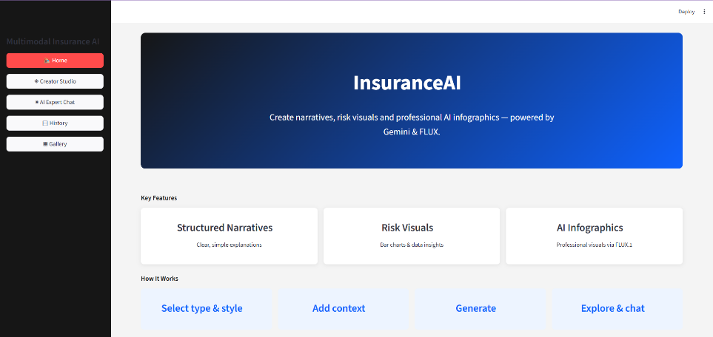

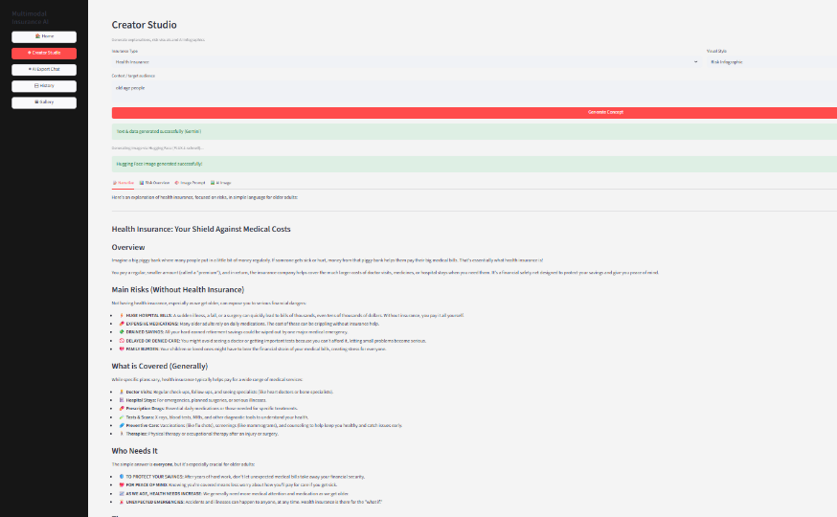

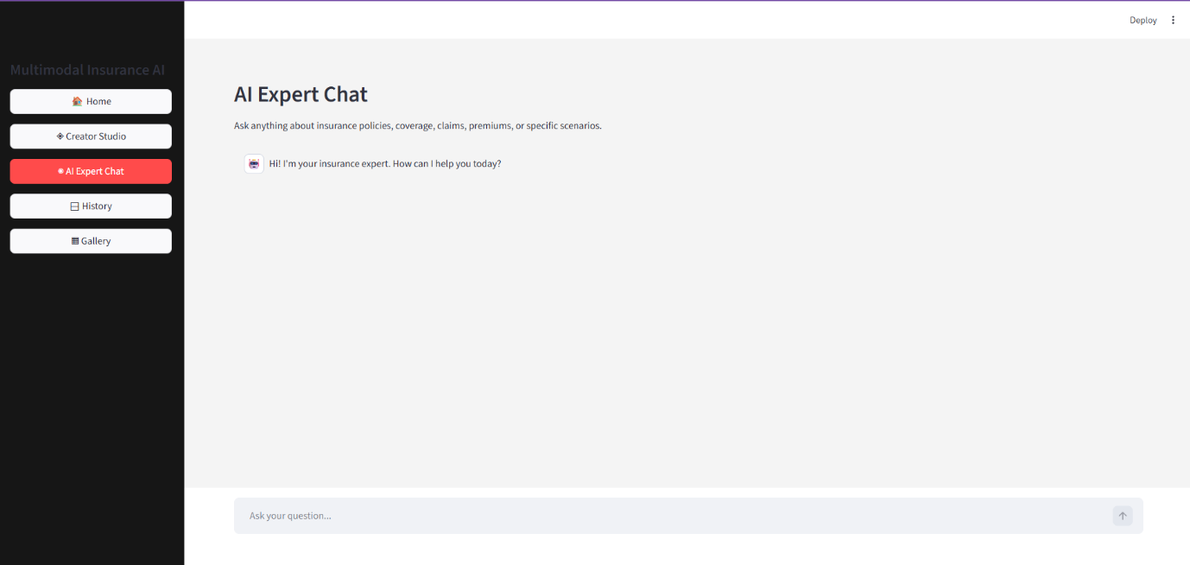

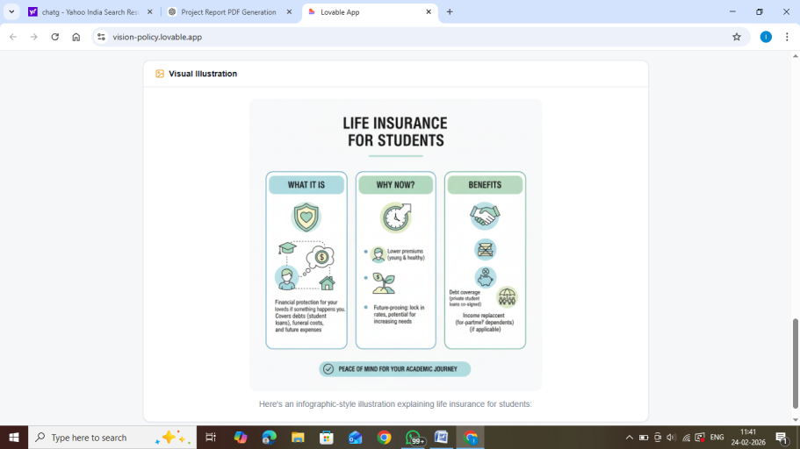

2. Reports / Dashboards / Models
- AI-based text generation model (Gemini API integration)
- Image generation model via Hugging Face
- Backend processing and prompt handling system
The system does not use traditional dashboards but focuses on intelligent content generation.

3. Key Outcomes
- Successfully developed a working multimodal AI system.
- Improved clarity of insurance explanation

- Reduced manual effort in understanding policies.
- Demonstrated integration of multiple AI APIs in one application.
- Achieved fast and accurate response generation.

Conclusion
The Multimodal Insurance Creator successfully addresses the challenge of understanding complex insurance policies. By combining AI-generated text explanations with visual representations, we created a system that makes insurance concepts more accessible and easier to understand.
Through this project, we gained practical experience in:
- API integration
- Prompt engineering
- Backend development
- AI-based system design
- Multimodal content generation
This project helped us understand how AI can be applied to solve real-world problems in the finance and insurance domain.

Future Scope & Enhancements
The project can be further improved in the following ways:
- Integration into real insurance company platforms
- Adding support for multiple languages
- Voice input and audio explanation features
- Mobile application development
- Personalized explanations based on user profile

- Integration with chatbot systems
- Storing user history for better recommendations
In the future, this system can be expanded into a full-scale AI-powered insurance assistant.

